Keswick Fieldcourse: Observing and characterising building stone decay
Building-stone decay
You will need:
- This guide.
- Pen, pencil and paper.
- Camera, or make sketches with pencil and paper.

Background

Stone weathering occurs out in ‘natural’ settings, such as bedrock exposures, erratic boulders and boulders within glacial moraines that can be observed close to Keswick in the Lake District. However, the stone that has been quarried and used as a building material in the urban environment is also subject to weathering, and it is this setting that you will be investigating today. Conserving buildings is important not only for extending the use of buildings that are in still in use today but also for conserving built heritage that exists as ruins. See Historic England webpages for background on the law, policy and guidance that exists to protect historic areas, sites, buildings and monuments to put this into wider context. https://historicengland.org.uk/advice/hpg/generalintro/

In order to protect and conserve buildings and built heritage we need to understand some of the science of the process of weathering, particularly getting a sense of the range of types of weathering and their rates. This allows practitioners to then able to predict how well stone buildings will persist into the future and the point at which we need to step in and conserve them. This conservation ultimately takes the form of replacing sections of stone, but before then measures can be taken to slow down decay.

Understanding the decay of urban stone heritage begins with visual assessment. This takes a geomorphological (the study of form and process of features on the earth) approach in which the processes responsible for the decay of the stone are used as categories. The Weathering Research Group’ in the School of Geography at Queens University Belfast suggest a 5-part categorisation of weathering features:
- Mechanical breakdown (2) Solution (chemical)
- Alteration/deposition (4) Biological
- Human damage
They also stress, that it is rare that these processes operate in isolation. These processes may be operating concurrently in combination, or in sequence through time.

Online resources for any budding stone weathering enthusiasts

There are two UK-, and republic of Ireland-based research groups that are particularly active in this research area: ‘The Weathering Research Group’ in the School of Geography at Queens University Belfast, and the ‘Rock Breakdown Laboratory’ in the School of Geography and the Environments at the University of Oxford.

Materials from Queens University, Belfast
http://www.qub.ac.uk/geomaterials/weathering/weatheringfeatures.html

ICOMOS-ISCS: Illustrated glossary on stone deterioration patterns.
https://www.icomos.org/publications/monuments_and_sites/15/index.htm
Your Activity

The sheet on the next page provides a key for you, with examples of each of these 5. Your task in your two groups is to:
- Observe the building stone types in Keswick and chose the appropriate categories from the appendix guide about weathering forms. Visit at least 10 sites.
- Insert your chosen categories into a table and record the frequencies that you observe these features in your chosen streets in Keswick. Also record notes about the stone type (colour, texture etc.).
- Take photographs or make sketches of examples of the features that you observe.
- Consider, and discuss the two questions within your groups as you conduct your observations.

Questions to think about and prepare some ideas around within your group:

- Which category of features is most commonly observed in Keswick? And can you suggest some reasons why this category is most common (for example, is it to do with the stone type, or the types of forces operating in this environment?).

- How might your observations have differed if you were looking at the building materials you have seen in your own home town/city/village etc.? What accounts for these differences?

When we meet back up at the end of the exercise, use your notes about your observations to feedback to the whole group about what you observed and your ideas around the questions posed. We’ll also spend a moment critiquing the methodology you employed and h

Recording sheet (follow this format, or design your own)
You may want to orientate a few pieces of paper to landscape.

 |  | Category
Location  (Street name and location) | Building Stone Type | Mechanical feature | Solution (chemical) | Alteration/ deposition | Biological | Human damage

Appendix

- MECHANICAL BREAKDOWN stone decay glossary
Stone decay feature | Code | Description of decay feature | Example
Blistering | BL | Surface is lifting away in discrete areas. Possible explanations:  - salt has gradually accumulated & crystallised at a shallow depth. Expansion and contraction due to repeated wetting and drying may lift the surface layer away from the underlying stone.  - formation of a case hardened outer layer to the limestone could cause the surface layer to expand and contract at a different rate to the underlying stone when heated and cooled. | 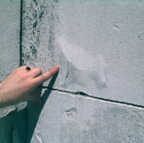  Portland limestone St Paul's Cathedral
Flaking (<5mm) | Fl | Small (< 5mm) pieces falling from surface.  - Most commonly associated with the rapid retreat of salt-laden stone.  - Often takes place in hollows formed as the stone weathers - might suggest flaking is associated with repeated shallow wetting and drying of the stone (e.g. condensation of overnight dew). | 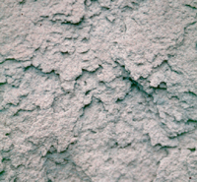
Scaling (>5mm) | Sc | Larger pieces.  - Scales often follow the surface detailing of a stone ('contour scaling').  - Often linked to the accumulation of salt at a frequent wetting depth within the stone and the eventual lifting away of the outer layer - this may first be manifested as a blistering of the surface (BL).  - Scales may also form when a hardened outer surface, e.g. an iron-rich alteration rind, breaks away from underlying stone that has been weakened by gradual loss of iron cement | 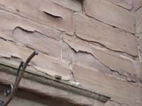
Granular Disintegration | GD | Occurs in granular (e.g. sandstone) and crystalline (e.g. granite) stones where  - the cement holding the grains together is weakened by solution, or  - where salts crystallise in pores to force individual grains apart.  Produces debris that is a mixture of salt and individual grains that is referred to as a 'rock meal' and can often be seen accumulating beneath stones that are actively decaying. | 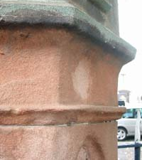
Honeycombs | Hb | Distinct appearance.  - Multiple flaking and granular disintegration, frequently associated with salt accumulation and are often found in humid, shaded areas where salts are protected from solution loss by rain and rainwash.  - May begin simply as a patch of stone that has different porosity characteristics and is more susceptible to weathering. However, once the stone starts to weather it creates a hollow that in turn encourages further salt retention ('positive feedback') means that salt weathering often results in the hollowing out of the stone to give a honeycomb appearance.  - As weathering continues, small depressions either merge or become overwhelmed by adjacent hollows. | 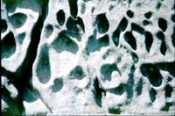
Caverns (Tafoni) | Cv | Larger hollows also develop that may eventually destroy complete blocks of stone.  - The same process of positive feedback.  - Size of caverns can be controlled on a building by the dimensions of individual blocks.  - Tafoni also occur on cliff faces in natural salt-rich environments and their dimensions may be related to the creation of hollows that provide the optimum environment, in terms of humidity, heating and cooling and salt deposition and retention, for salt weathering to occur. | 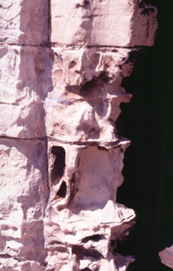

(2) SOLUTION/ CHEMICAL BREAKDOWN stone decay glossary
Stone decay feature | Code | Description of decay feature | Example
Suface loss | SL | - On a uniform limestone surface it is sometimes difficult to see whether it has been subject to solution.  - Where the stone contains fossils such as the shell fragments (e,g. Portland limestone) these are formed of a highly crystalline calcium carbonate known as 'sparrite'. This dissolves more slowly than the micro-crystalline 'micrite' that makes up the rest of the stone and as the surface is lowered the fossils are left standing above it. | 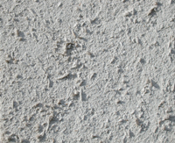
Staining | St | - In mixtures of stone types in a building (e.g. Portland limestone decoration set into a brick façade in the photo) the products of solution from the limestone can wash over and contaminate the underlying material.  - This is potentially damaging, as salts can crystallise within masonry and cause decay. This combination of materials also means that the bricks become subject to salt attack, even though they themselves do not react with pollutants to form salts. | 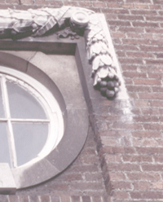
Pitting | Pt | - Occurs in dry environments, or in the sheltered areas of wetter climates.  - Examination under high magnification by scanning electron microscope often reveals that the interiors of these pits are colonised by communities of algae, fungi and bacteria. These help to dissolve the stone, and create tiny niches (+ feedback). | 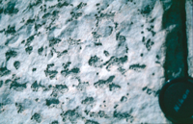  Surface of a limestone monument, E Turkey.
Scalloping/ Fluting | SF | - As water flows over the surface of a limestone the patterns of flow (turbulence) in the thin film of moisture mean that the rate of solution is uneven and gradually the flow patterns are translated into complex wave-like shapes on the stone surface. | 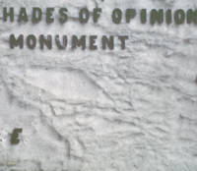  Marble headstone from a graveyard in Belfast.
Recrystallisation | X | - If a film of rainwater is left on a limestone and allowed to evaporate, any calcium carbonate in solution will re-precipitate as crystals of calcite. Leaves a clean surface that has a typically sparkling appearance as light is reflected off the crystals. | 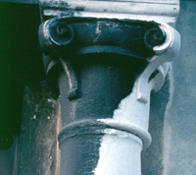  limestone pillar on St Mark's Bassilica in Venice. White side, exposed to rainwash is in sharp contrast to the black gypsum crust.

(3) ALTERNATION/ DEPOSITIONAL stone decay glossary
Stone decay feature | Code | Description of decay feature | Example
Efflorescence | Ef | - If stonework, contaminated with salt, is wetted and then dried very slowly, the salts can be dissolved, brought to the surface and precipitated by evaporation to produce a typically white salt efflorescence.  - This may also form from other processes, e.g. where rising groundwater containing salts moves up through stonework.  - Can result in granular disintegration. | 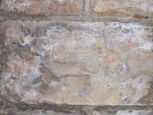
Cryptofloresence | Cf | - Formed of salts that crystallise within the stonework and for the most part are hidden from view. They are revealed when they cause the detachment of the overlying surface layer by contour scaling.  - Salt crystallisation at depth may be related to the frequent wetting of the stone to a consistent wetting depth and crystallisation as the stone rapidly dries out. | 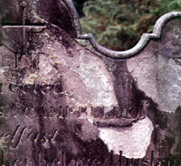
Rock Meal | RM | - Granular disintegration of stonework often results in the formation of a crumbly layer of mixed salt and rock debris. This can be often can be seen accumulating below the weathering stone. (e.g. photo of rock meal loosely attached to the interior of a rapidly weathering tafoni). | 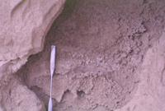
Alteration Rind | AR | - These rinds can be very complex and often result from the slow chemical alteration of the outer layer of an outcrop or boulder. On buildings the most common example of this is found on stones such as iron-rich sandstones  - Once this crust is breached the weakened stone underneath is very susceptible to processes such as salt weathering. (photograph J.M. Curran) | 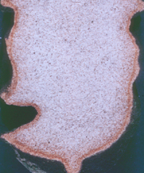
Case Hardening | CH | - This is a particular form of alteration rind found principally on limestones, in which a dense outer skin is formed by the outward migration in solution and re-precipitation of calcium carbonate.  - This does not change the chemistry of the stone, but can significantly decrease surface porosity and strengthens the outer layer.  - If case hardening has occurred at the expense of weakening sub-surface material, the breaching of the crust can ultimately accelerate decay. (photograph B.J. Smith) | 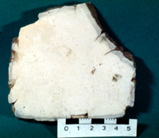
Iron Staining | IS | - Mobilisation of iron described in the formation of alteration rinds also has the indirect effect of changing the surface colour of the stone. Often this is a fairly uniform process and contributes to the slow formation of a surface patina that is indicative of a mature building.  - The picture shows a house in Edinburgh after it has been 'cleaned' to leave uneven and unsightly staining by iron that was mobilised and brought to the surface during conservation. (photograph B.J. Smith) | 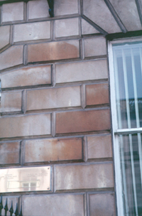
Black Crust | BC | - Form where gypsum (calcium sulphate) crystallises on a stone surface in a polluted environment. As it does so it can incorporate pollution particles that give the deposit its characteristic blackness.  - Frm best on limestones where the calcium carbonate can be transformed to gypsum in a sulphate-rich atmosphere.  - Ca also grow on non-calcareous stones where, for example, they become loaded with calcium washed in from adjacent limestones and mortars or blown in as dust particles. | 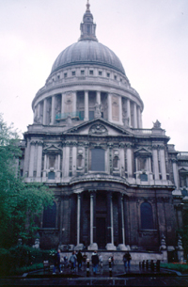
Grey Crust | GC | - May simply represent an early stage in the development of a black gypsum crust. Some experiments have shown that these thinner crusts can form a relatively dense surface covering that contrasts with subsequent black crusts.  - The picture shows the crust developing in sheltered areas, but old photographs suggest that in many cities prior to clean air legislation the deposition of gypsum and particles was so rapid that it could survive rainwash and many buildings developed a complete grey/black crust. | 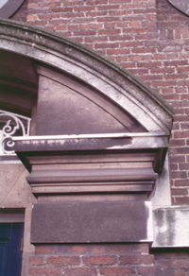
Black Encrustation | BE | In extreme cases of high levels of pollution and/or long time periods, black crusts can continue to grow. Ultimately the gypsum develops into a thick encrustation that is often described as botryoidal (grape like) in appearance, that both covers and hangs from the stonework. (photograph B.J. Smith) | 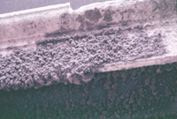
Flowstone | Fl | - Where water percoates through stonework it follows the porous network of mortared joints. Where moisture leaks out it can precipitate dissolved material.  - This can lead to the contamination of underlying stonework with salts such as gypsum. Where Portland cement has been used - either originally or during re-pointing - this can lead to the precipitation of deposits of calcium carbonate which resemble the 'flowstones' that form on cave walls. | 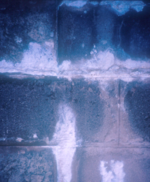
(4) BIOLOGICAL stone decay glossary
Stone decay feature | Code | Description of decay feature | Example
Lichen | Ln | - Lichen are a common feature of old stonework, generally best developed under clean air conditions, but growth may be facilitated by certain pollutants such as nitrogen oxides.  - Opinions on their significance vary. Some consider that they help to chemically weather the underlying stone and to physically damage the stone by plucking out grains as they dry out. Others point out that lichens require a stable substrate and take a lichen cover to indicate surface stability. | 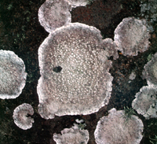
Epilithic Algae  (also see pitting under the solution category.) | EpA | - Epilithic algae grow on the surface of a stone and can promote the solution of stones such as limestones. Frequently associated with dampness and patches may develop where, e.g. where, rainwater concentrates and flows.  - Under warm, moist climatic conditions a complete cover of algae may develop.  - In dry environments, algae may grow as discrete colonies and, through preferential solution, create pits in limestones that in turn favour further algal growth.  - Some forms of chemical cleaning of stones such as sandstones might encourage algal growth, by opening up pores and loading stones with a residue of potential nutrients.
Endolithic Algae | EnA | Provided sunlight can penetrate, algae can live within the pores of the stone.Within the stone algae can promote processes such as the dissolution of inter-granular cements.
Vegetation | Vn | If building facades are not maintained vegetation will eventually colonise sheltered areas by extending roots into joints and fractures. As the roots grow they can widen these joints and cracks to force stone apart. They may also encourage dampness that exacerbates other processes such as salt weathering. (photograph J.M. Curran) | 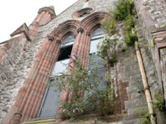
(5) HUMAN DAMAGE to stone glossary
Stone decay feature | Code | Description of decay feature | Example
Repair | Rr | Picture shows the effects of re-pointing a relatively soft stone with a hard cement mortar. This rigid mortar provides a rigid boundary to the stone block by which the stone is constrained when it expands and contracts in response to heating/cooling and wetting/drying. Eventually the stone fails and begins to retreat through, in this case, multiple flaking. | 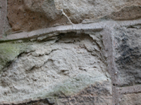
Cleaning | Cl | This picture shows the consequences of power-hosing a cover of epilithic algae from a soft, weathered sandstone. | 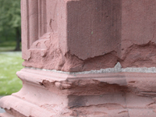
Corrosion of metal fixings |  | The picture shows the result of the rusting of an iron fixing for a gate in a sandstone wall. Water soaking into the sandstone allowed the oxidation and expansion of the fixing which eventually caused the catastrophic failure of the enclosing stone. | 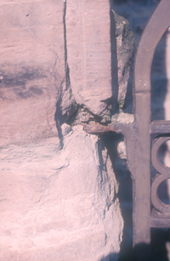
War damage |  | The picture shows bullet damage to a limestone wall in Budapest that was caused during the siege of the city in 1945. Note how black crusts have developed in the sheltered interiors of the bullet holes. | 