WATER QUALITY

What is water quality?
The physical, biological and chemical characteristics of water.

Why measure water quality?
- Drinking water quality/human contact
- Health of ecosystems
- Detect long term trends/anomalies
- Understand processes

What determines water quality?
- Interactions between soils, vegetation and geology
- Rainfall and atmospheric inputs (e.g. acid rain)
- Anthropogenic sources (e.g. agricultural fertilisers, sewage effluent)
- Hydrology

What can we measure?
- pH
- Conductivity
- Dissolved oxygen
- Colour
- Biological indicators
- Sediment volume
- Other more complex parameters, such as toxic metals

How can we measure it?
- Probes or sensors in the field
- More advanced analytical equipment in the lab.
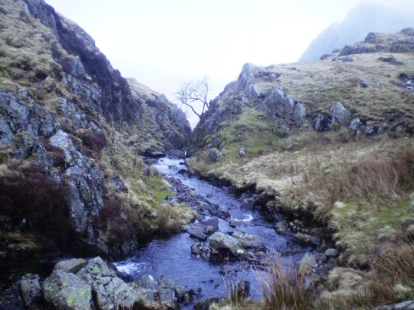
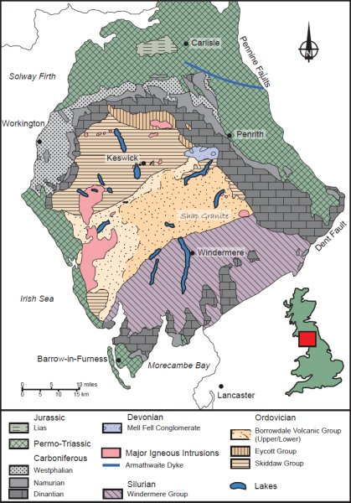
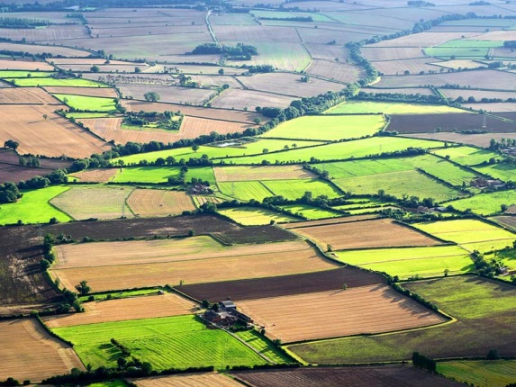
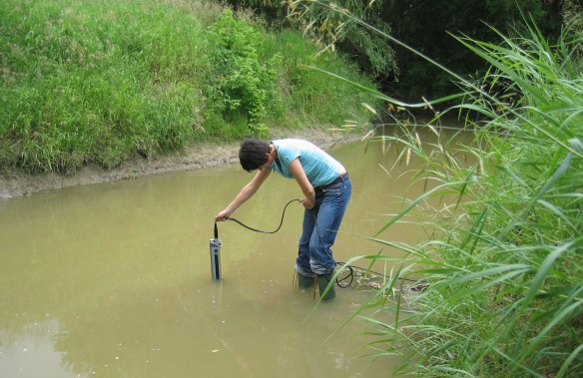

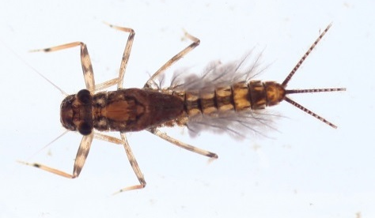
Mayfly Nymph
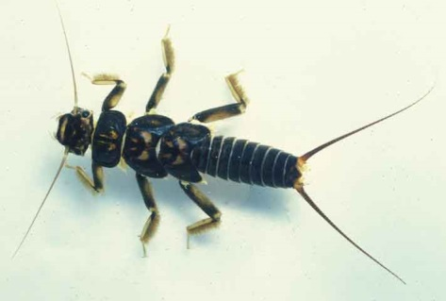
Stonefly Nymph
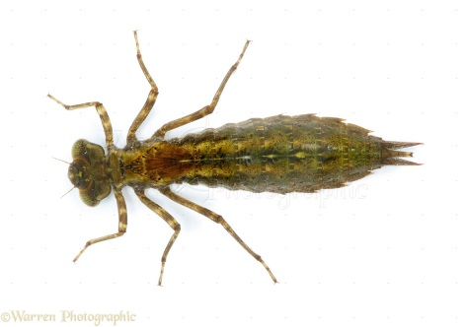
Dragonfly Nymph
CLEAN

COMMON AQUATIC INVERTEBRATES

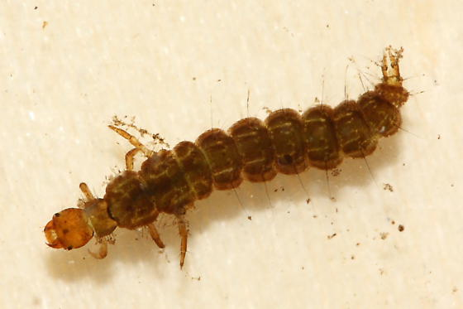
Caddisfly
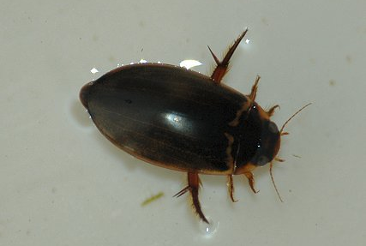
Water beetle

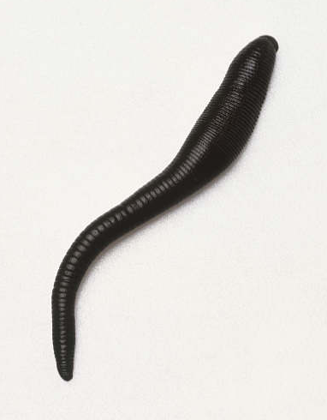
Leech
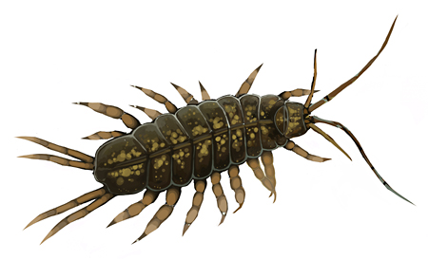
Hoglouse
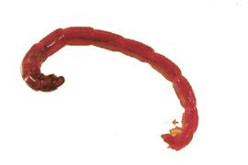
Bloodworm

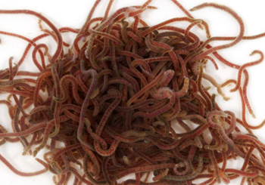
Worms

POLLUTED

RESULTS

 | Mayfly | Stonefly | Dragonfly | Caddisfly | Water Beetle | Leech | Hoglouse | Bloodworm | Worms
Site 1
Total
Site 2
Total

Questions

1. Which is the most common invertebrate?
2. Is there a difference between the two sites?
3. Is water quality affected by the Field Centre?
4. How could you improve the sampling strategy?

